<https://tpchd.org/healthy-people/food-safety-for-consumers/power-outages-at-home/>

[Home](https://tpchd.org/) » [Healthy People](https://tpchd.org/healthy-people/) » [Consumer Food Safety](https://tpchd.org/healthy-people/food-safety-for-consumers/) » **Power Outages in Your Home**

**Power Outages in Your Home**

**Plan for an emergency before it happens.**

**Prepare for power outages:**

* Create an emergency kit with battery-powered radio, light sources, and extra batteries.
* Never use barbecues or portable or propane heaters inside. They create carbon monoxide which can cause suffocation.
* Register life-sustaining medical equipment with your utility company.

**Keep food safe:**

* Store food carefully to prevent foodborne illness when power outages make refrigeration unavailable.
* Use food that can spoil rapidly first.
* Keep refrigerator and freezer doors closed.
* Use an ice chest packed with ice or snow to keep food cold.
* Buy dry ice to save frozen food. Do not handle dry ice with your bare hands.
* Use blocks or bags of ice in your refrigerator.
* Use caution if storing food outside during winter to keep it cold.
* Secure food stored outside to prevent contamination by animals.
* If in doubt, throw it out. Throw out meat, seafood, dairy products and cooked food that doesn’t feel cold.
* Never taste suspect food. Even if food looks and smells fine, illness-causing bacteria may be present.

[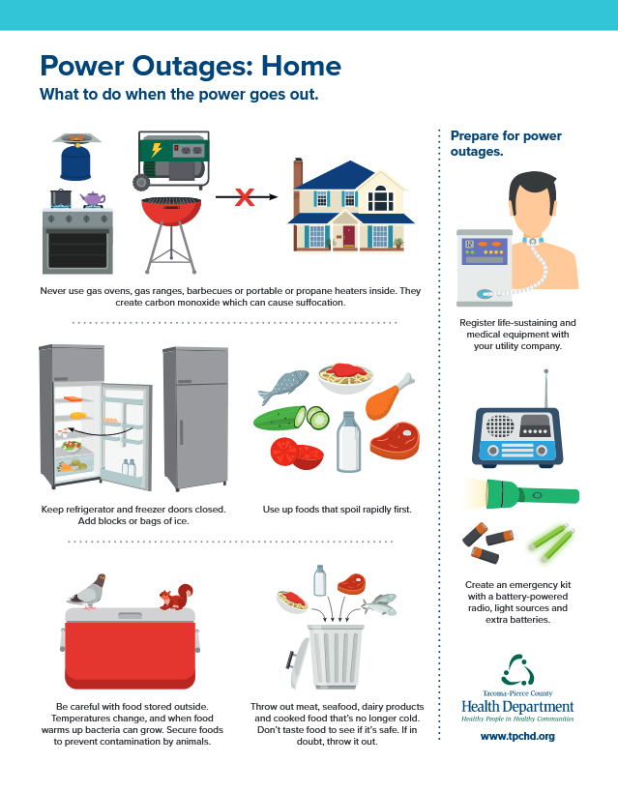](https://tpchd.org/wp-content/uploads/2024/04/Power-Outages-Home.pdf)

**View our Power Outage at Home handout.**

* [English.](https://tpchd.org/wp-content/uploads/2024/04/Power-Outages-Home.pdf)
* [Español (Spanish).](https://tpchd.org/wp-content/uploads/2024/04/Power-Outages-Home-Spanish.pdf)
* [한국어 (Korean).](https://tpchd.org/wp-content/uploads/2024/04/Power-Outages-Home-Korean.pdf)
* [Русский (Russian).](https://tpchd.org/wp-content/uploads/2024/04/Power-Outages-Home-Russian.pdf)
* [Tagalog (Filipino).](https://tpchd.org/wp-content/uploads/2024/04/Power-Outages-Home-Tagalog.pdf)
* [Tiếng Việt (Vietnamese).](https://tpchd.org/wp-content/uploads/2024/04/Power-Outages-Home-Vietnamese.pdf)

**Questions?**

Contact our Food Safety Program at [food@tpchd.org](mailto:food@tpchd.org) or (253) 649-1417.

**Resources**

* [Emergency Preparedness.](https://tpchd.org/healthy-places/emergency-preparedness/)
* [Learn how to prepare and be safe during an emergency, Department of Health.](https://doh.wa.gov/emergencies/be-prepared-be-safe)
* [Food Safety in a Disaster or Emergency, FoodSafety.gov.](https://www.foodsafety.gov/keep-food-safe/food-safety-in-disaster-or-emergency)